**SDM Assignment 1**

1. Create Repository In github

* At right most corner click on + sign
* Click on new repository

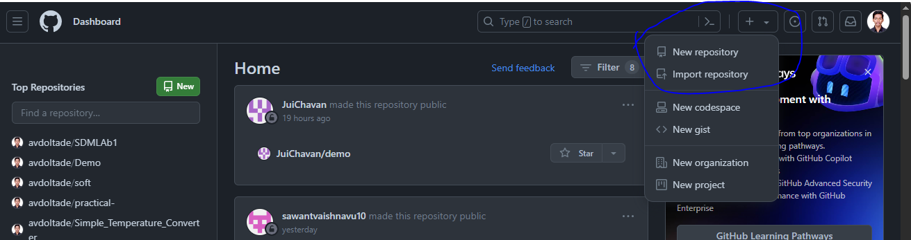

* Enter your Repository Name
* If you choose **public** that means Anyone on the internet can see this repository. You choose who can commit.
* If you choose **private** that means You choose who can see and commit to this repository.
* At last click on create repository

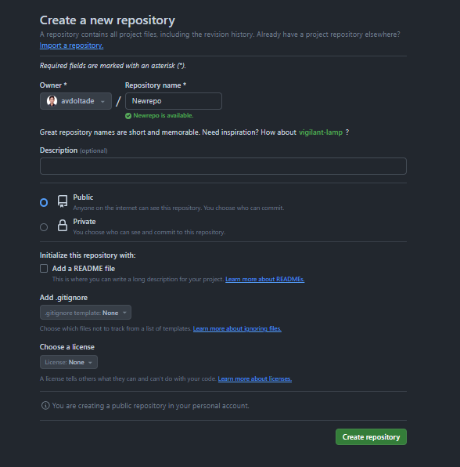

* Now you see newly created repository.

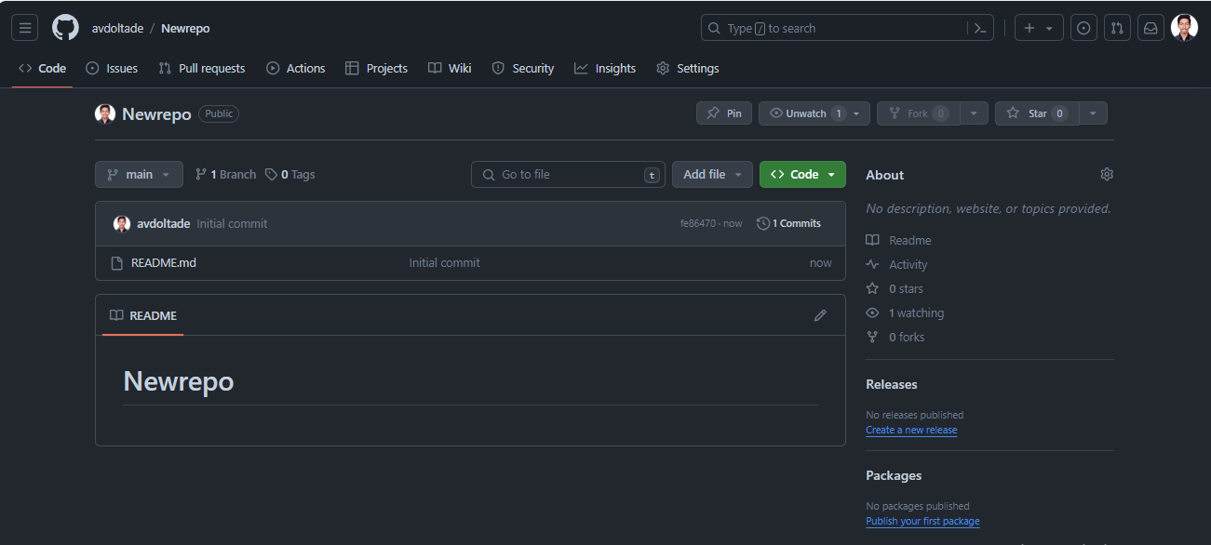

* Now click on code. After clicking code we can see our repository github link
* Then next step is to copy this link this link helps to cloning the data into our local machine.

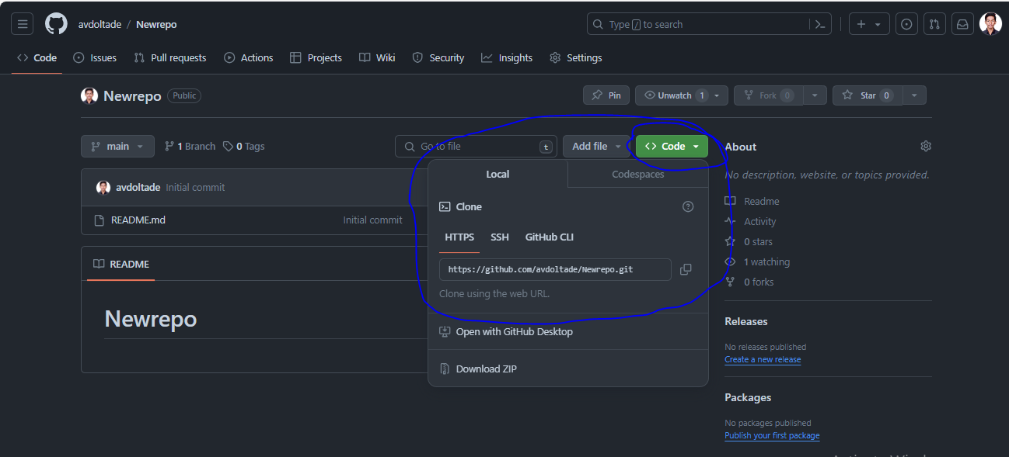

* Then open folder where we want to clone this repository
* Open cmd from that particular folder path

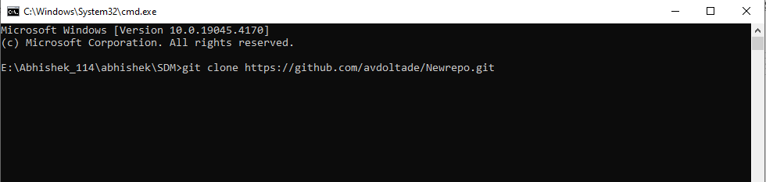

* Then type git clone command and paste git repository link and hit enter

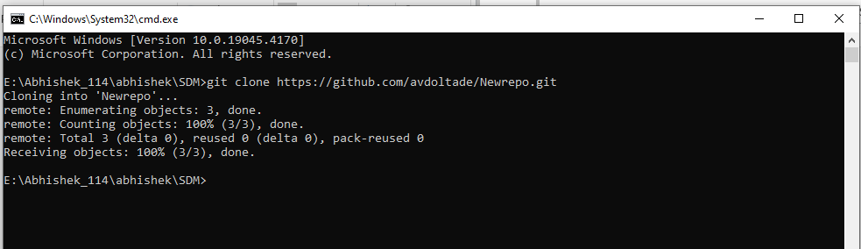

* Successfully clone repository data into our local machine folder

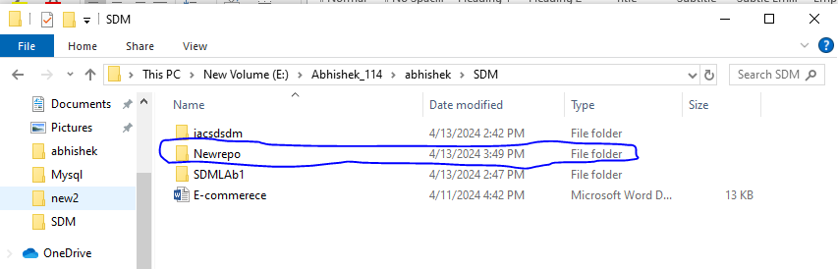

* Add folders inside Newrepo

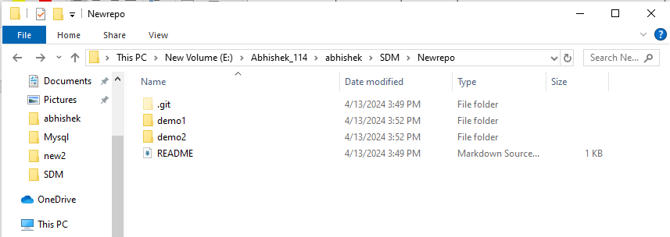

* Open cmd from newrepo
* Then type in cmd **git status** which shows status of the newrepo
* It shows 2 new folder that we created newly in Newrepo

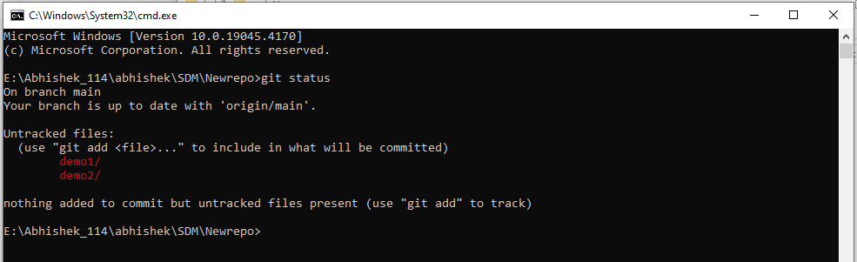

* Then enter **git add** command

The git add command is used to add file contents to the Index (Staging Area).

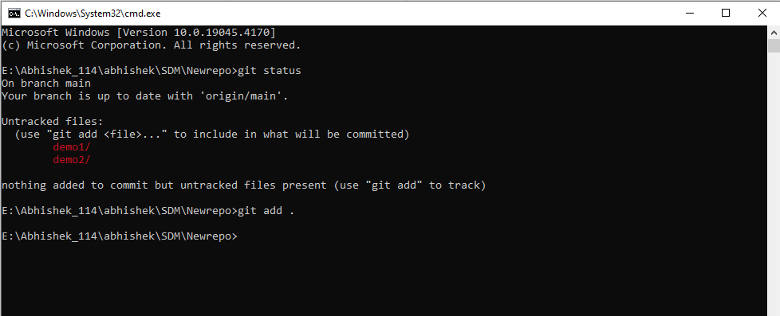

* Again checking the status of newly created folder added at staging area

enter **git status** command

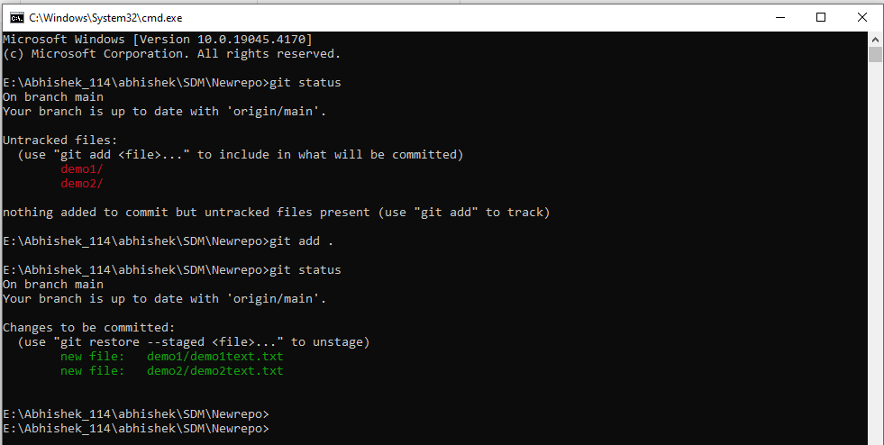

* A commit command is used to fetch updates from the staging area to the repository.

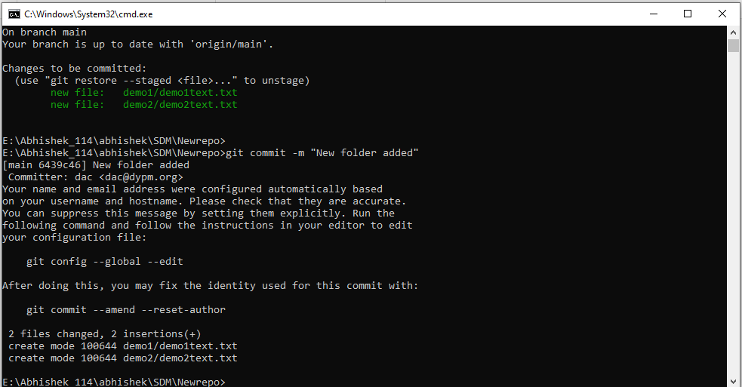

* Contain commites in staging area they are pushed to github repo by using **git push** command

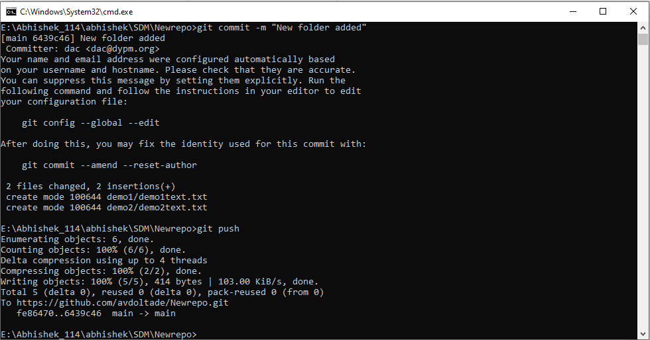

* It will successfully Pushed in github repository

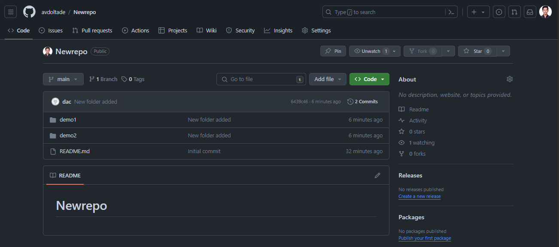

* If you want to Branch Particular Repository in Github.

We can do it 2 ways one is Command line through and 2nd one is github

We created Branch using cmd

Git merge:

● To crete new branch from existing branch

-git branch

● To check current branch

-git branch task1

To create new branch

-git checkout task1

To go to particular branch

● To push (local)taks1 to git

-git push -u origin task1

● To merge into Main branch on git

Create pull reques t-> Merge Pull request -> confirm merge

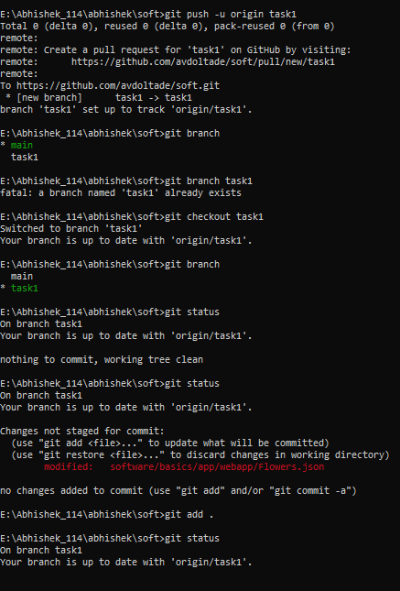

**Atlassian Jira**

* Login into Atlassian Jira Platform

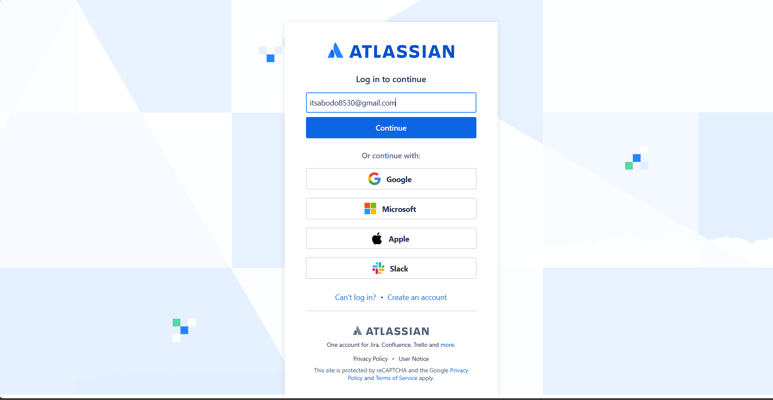

* Click on left 9 dots and click on Jira software to create a project in Scrum or other methods. Depends on your needs.

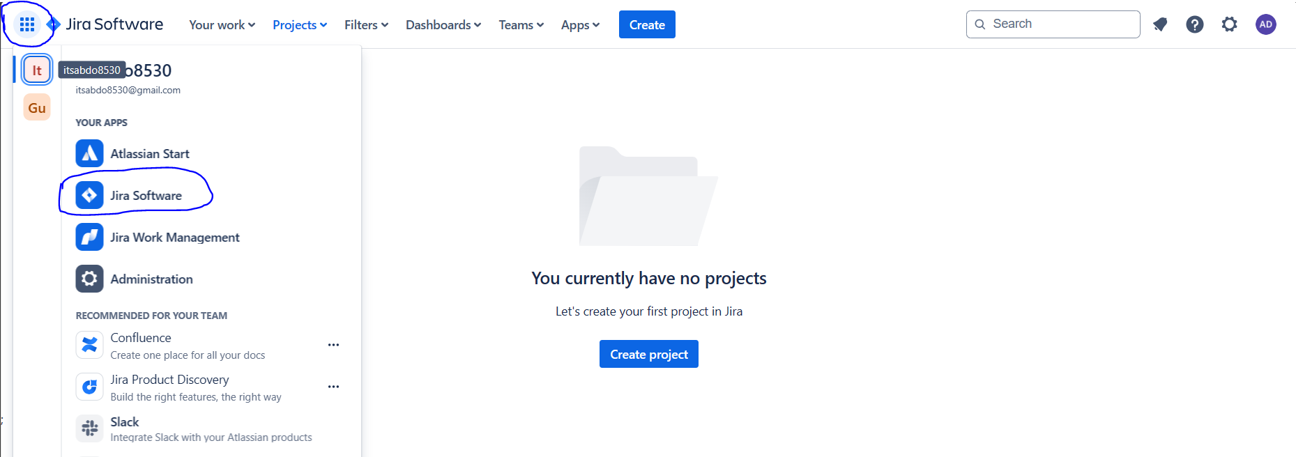

* Click on software development

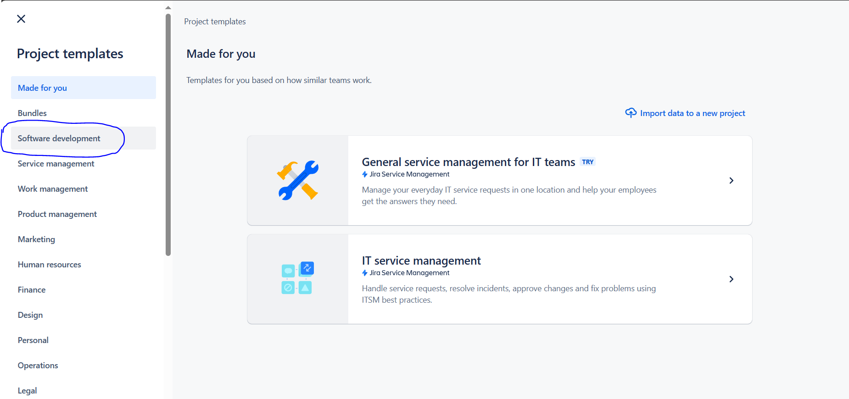

* Click on scrum.

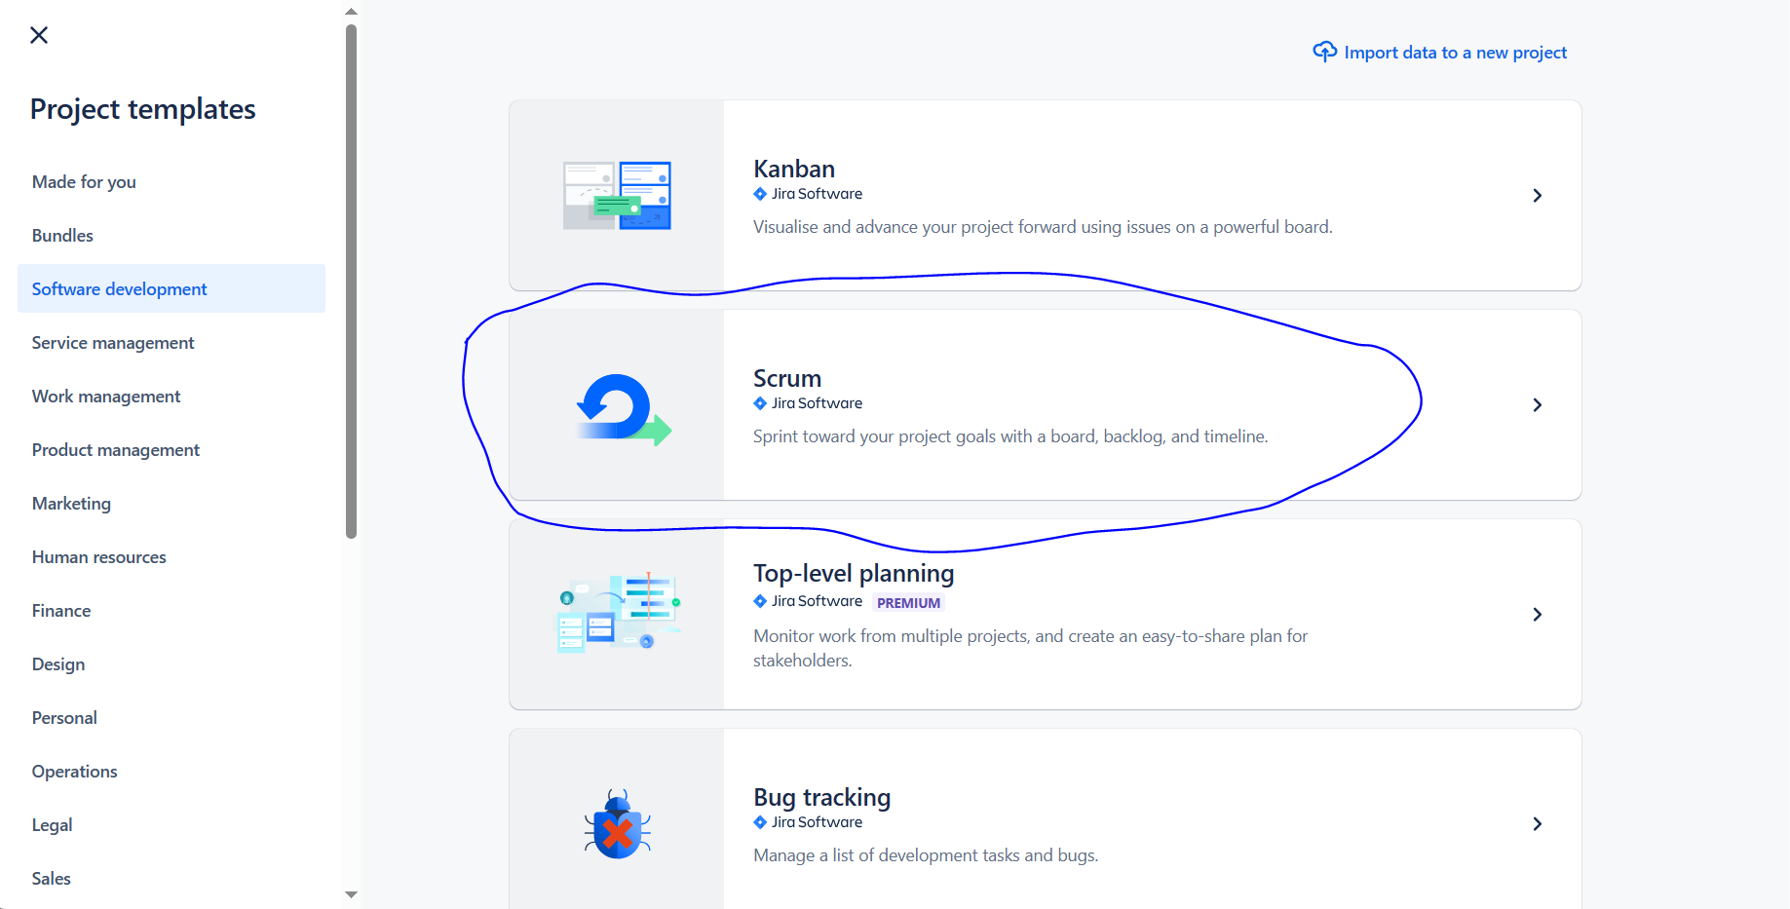

* Click on use template Button

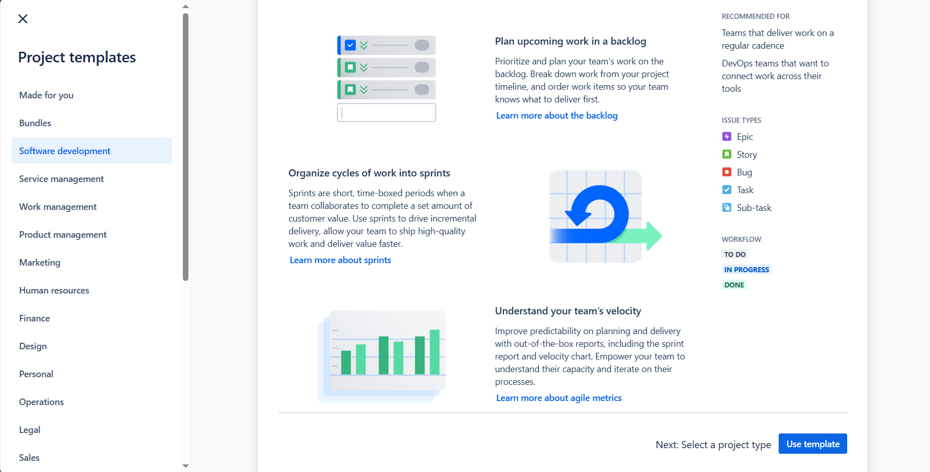

* Click on team-management project

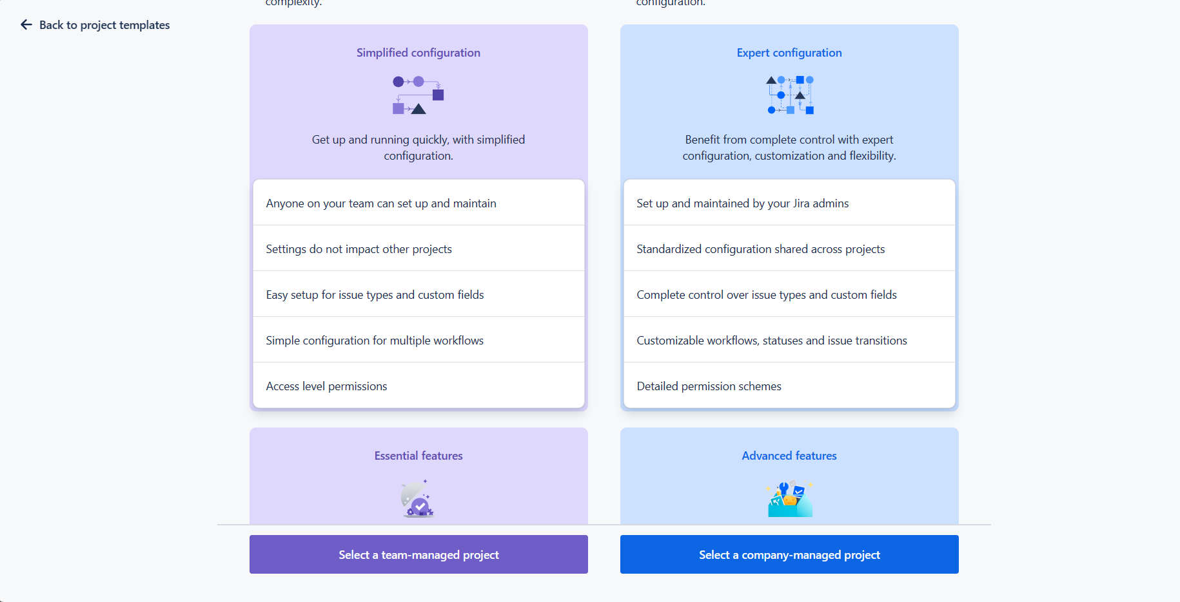

* Give project Name and click on next button.

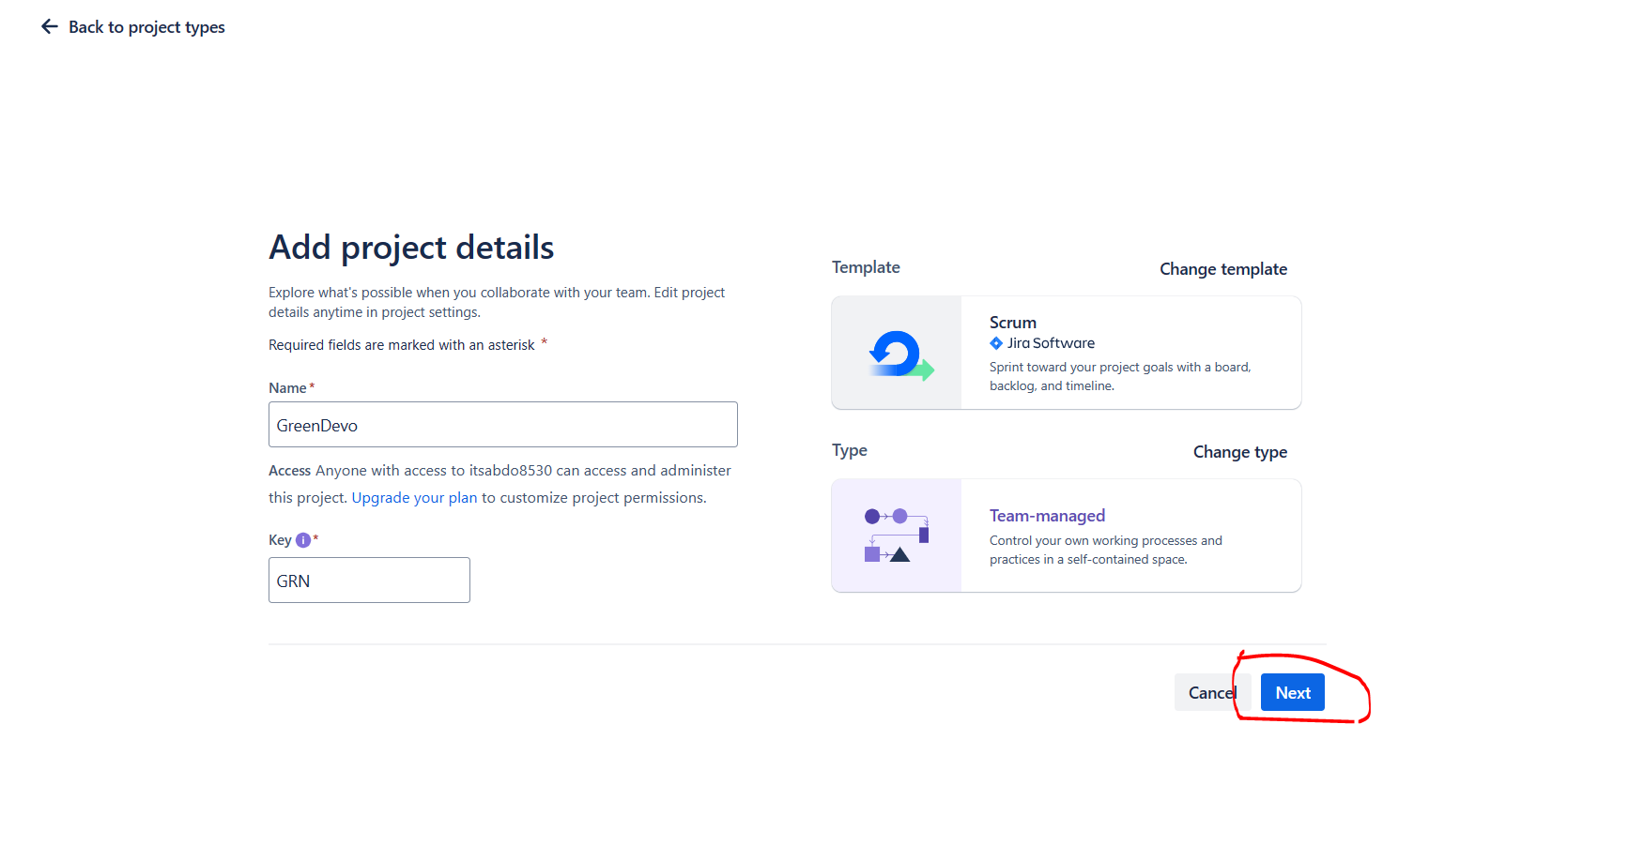

* It will show like this interface and then click on go to backlog.

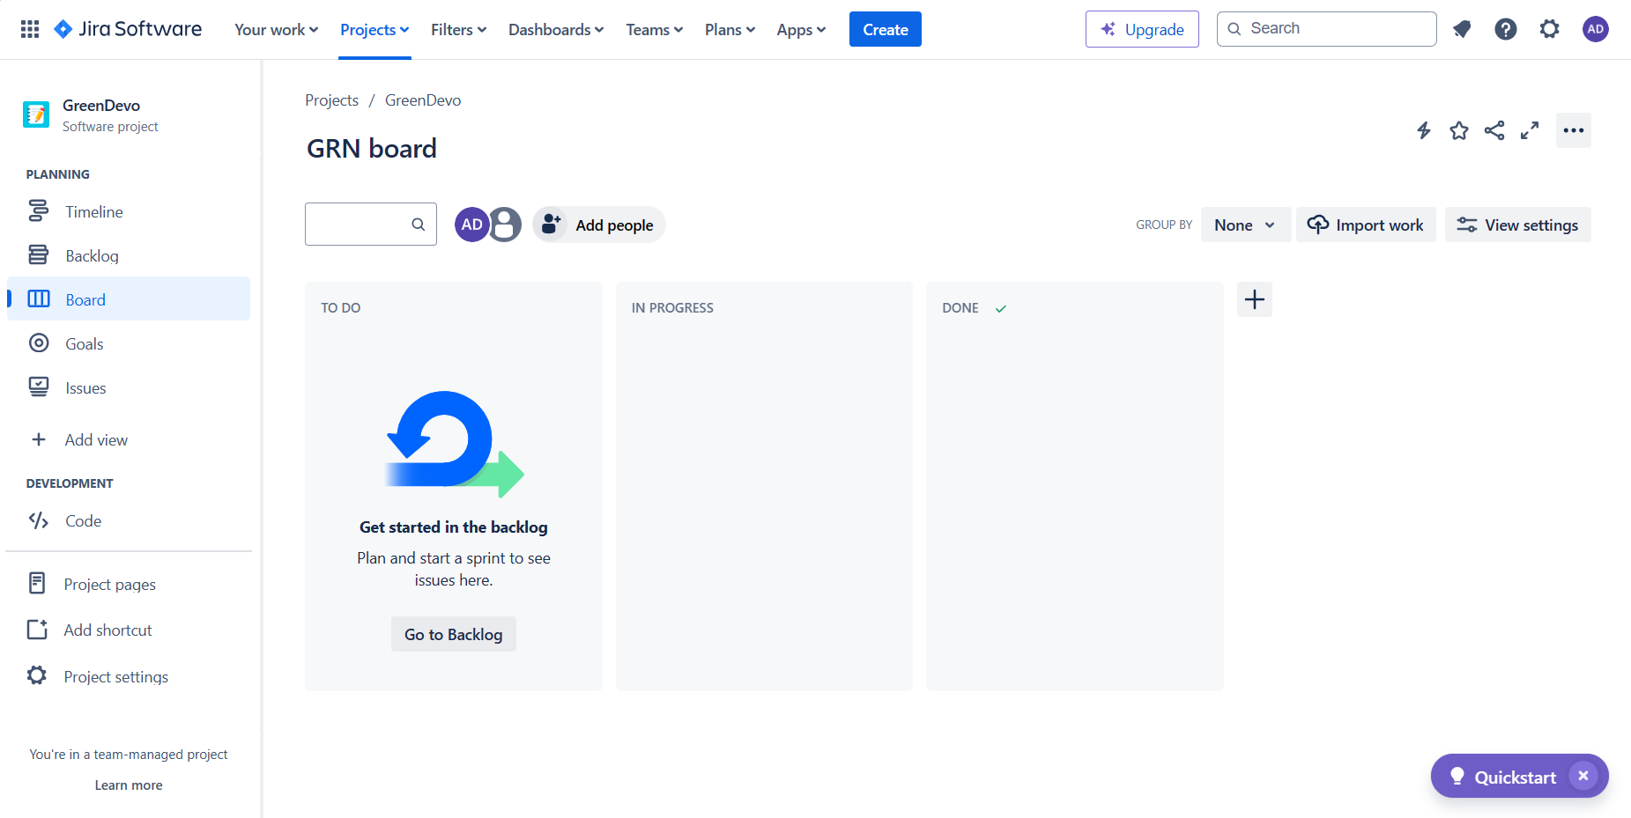

* Write a user stories scenarios in the backlog section and hit enter

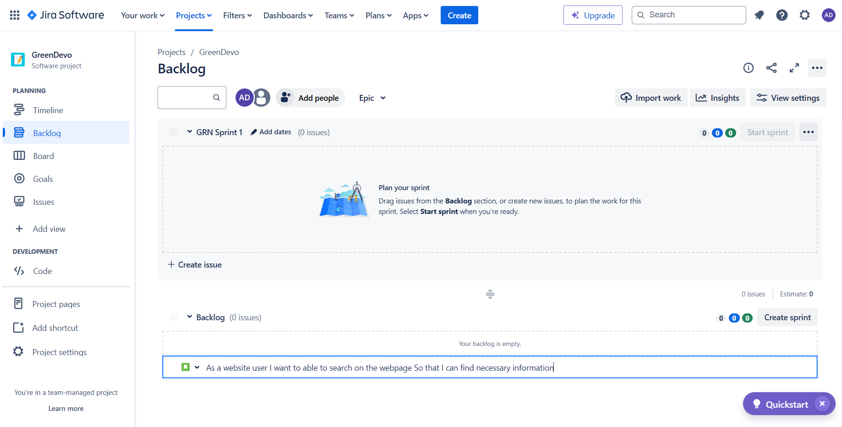

* Next step is to move to the sprint mode you simply drag user stories scenarios from the backlog and drag to the sprint mode it will move to the sprint mode.

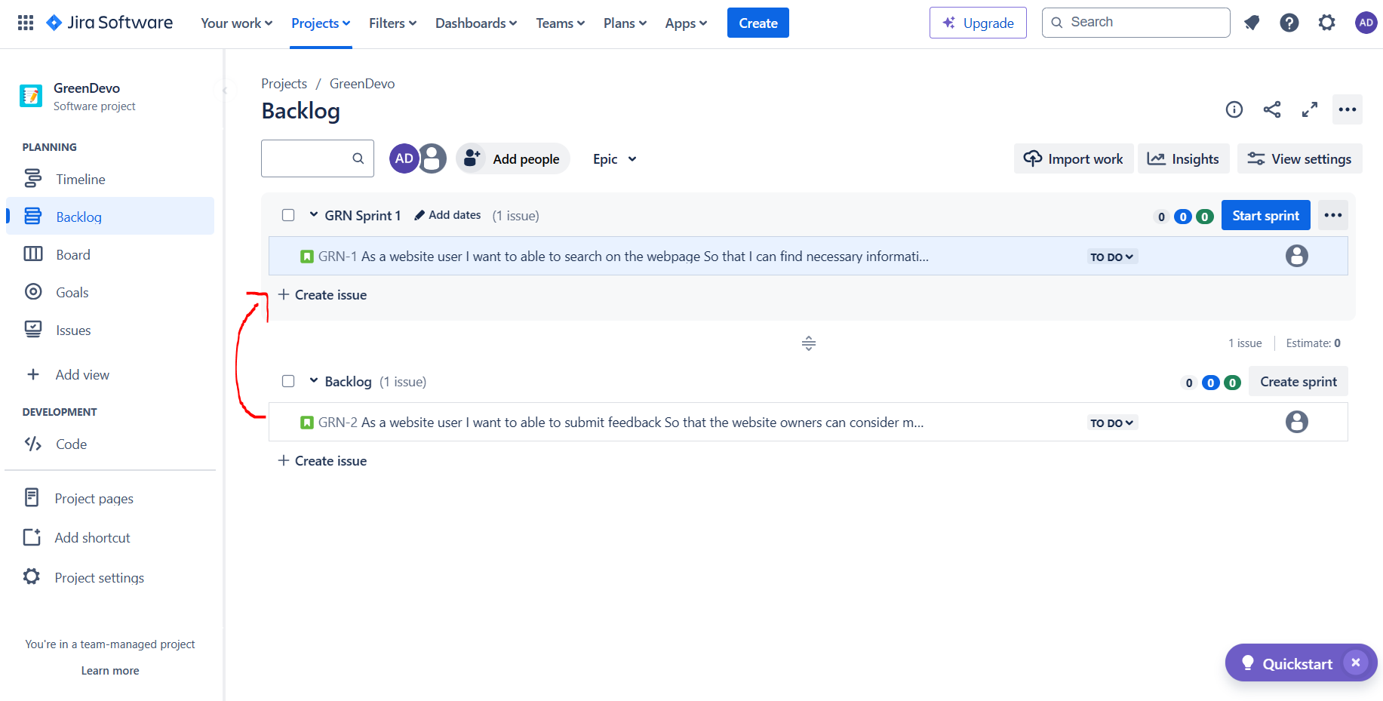

* Then start the sprint

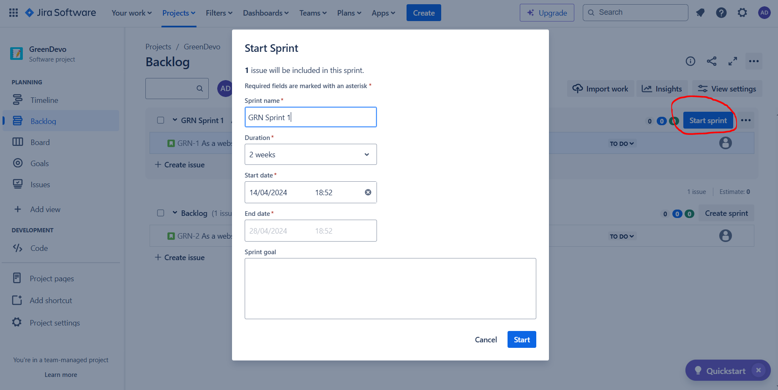

* It starts the sprint

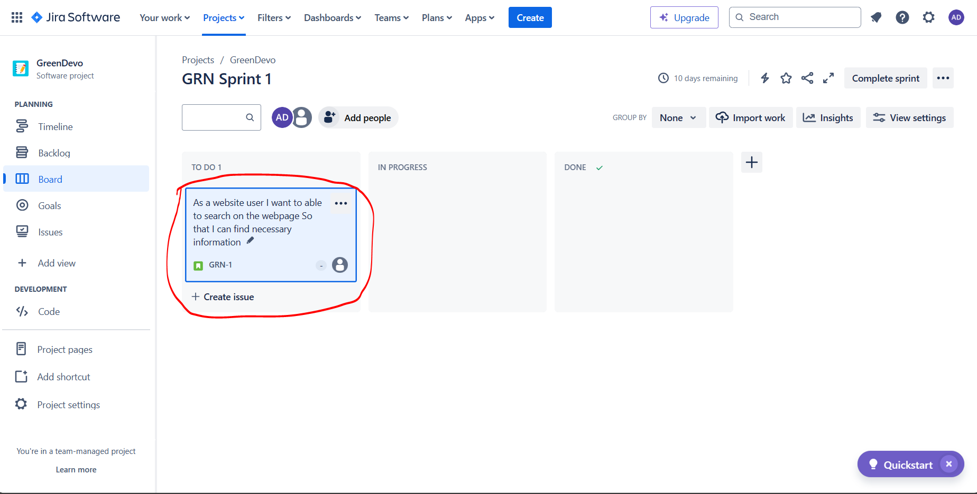

* To add the people into the project click on add people. It will add the people on the project.

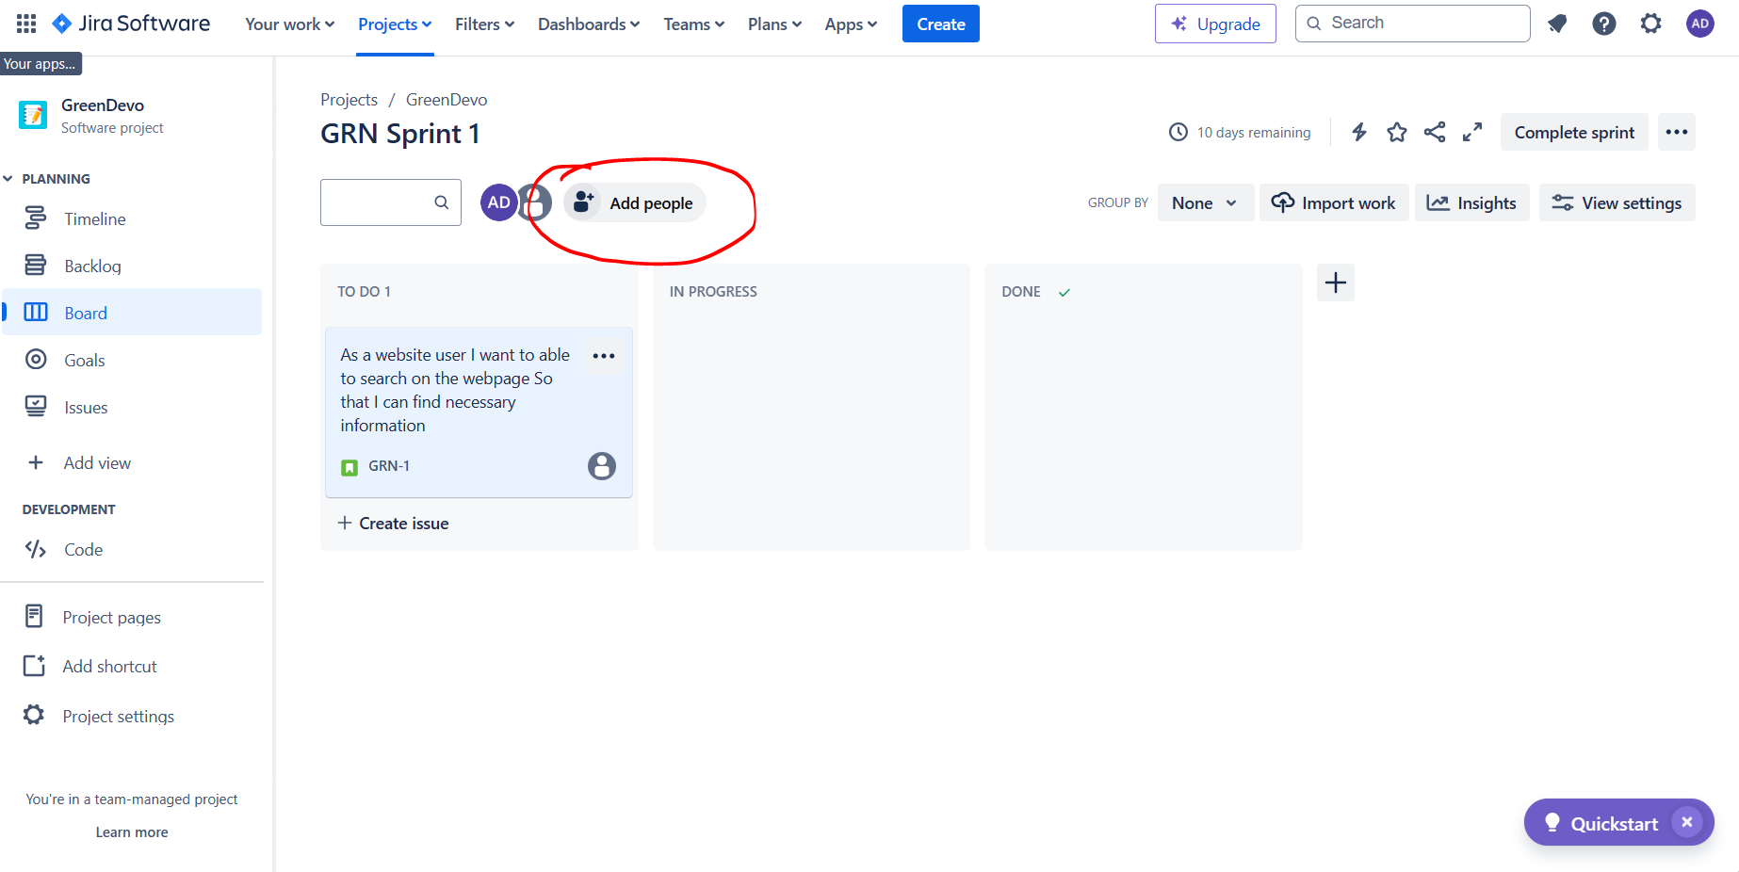

* Click on add people.

